Supplementary File 1
Piloting Exercise: Ovid EMBASE
Subject heading mapping
Date: 03.04.25
“clinical trial, phase III” - phase 3 clinical trial (Embase Classic+Embase)
“antibodies, monoclonal” - monoclonal antibody (Embase Classic+Embase)
“alzheimer’s disease” - Alzheimer disease (Embase Classic+Embase)

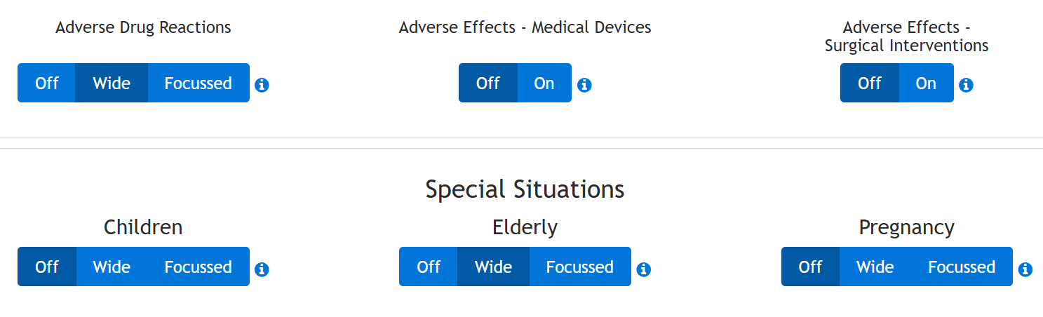

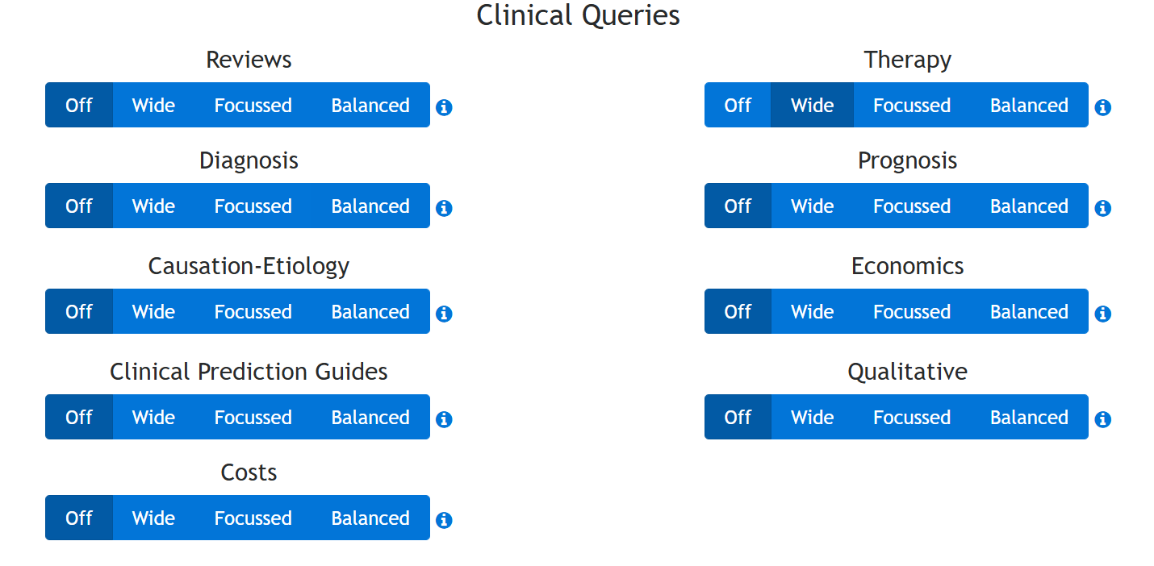

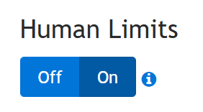

Initially, the first 5 hits from the search were exported to Covidence but after a discussion with CW, this was abandoned. Instead, every 10th study was extracted from the database so the piloting exercise would be more representative of the spread from the search

Piloting Exercise Results: Title and Abstract Screening

The studies in which CW and OO were not initially in agreement
 | Study Title | Include? | Reason
1 | Baseline characteristics for clarity-ad: A phase 3 placebocontrolled, double-blind, parallel-group, 18-month study evaluating ban2401 in early Alzheimer's disease | Yes | Meets the inclusion criteria
2 | A Path to Improved Alzheimer's Care: Simulating Long-Term Health Outcomes of Lecanemab in Early Alzheimer's Disease from the CLARITY AD Trial | No | Not a Phase III RCT
3 | Change in Digital Cognitive Test Performance between Solanezumab and Placebo Groups in Preclinical Alzheimer's Disease: Secondary Analyses from the A4 Study | No | Not a Phase III RCT
4 | Trial of solanezumab for mild dementia due to Alzheimer's disease | Yes | Meets the inclusion criteria
5 | Isolated ARIA-H in patients treated with lecanemab in the phase 3 clarity AD study in early Alzheimer's disease | Yes | Meets the inclusion criteria
In the piloting exercise, CW and OO initially had an agreement of 2/5. The piloting exercise was conducted by OO first assigning the studies as ‘include’, ‘exclude’ and ‘maybe’ in Covidence and then shared the Covidence screening with CW.
1 - OO initially said it was to be included as it met the inclusion criteria but that was incorrect as when discussed with CW, it did not report on the AD COS measures. This article was excluded.
2 - CW initially said yes but in the abstract, the study stated that it was a simulation model and thus, not eligible based on our inclusion criteria. This article was excluded.
5 - OO initially thought yes but on closer inspection to the abstract, this was the secondary analysis to a main study. This article was excluded.

Search Strategy
Database/ Registry | Platform | Date of Search | Number of Hits
Medline | PubMed | April 14th 2025 | 88
Embase | Ovid | April 14th 2025 | 72
ISRCTN | ISRCTN registry | April 14th 2025 | 6
Total | 166

Medline PubMed

Search Terms | Results
((Clinical Trial, Phase III) AND (Antibodies, Monoclonal)) AND (Alzheimer Disease)  ("clinical trial, phase iii"[Publication Type] OR "clinical trials, phase iii as topic"[MeSH Terms] OR "clinical trial phase iii"[All Fields] OR "phase iii clinical trial"[All Fields]) AND ("antibodies, monoclonal"[MeSH Terms] OR ("antibodies"[All Fields] AND "monoclonal"[All Fields]) OR "monoclonal antibodies"[All Fields] OR "antibodies monoclonal"[All Fields]) AND ("alzheimer disease"[MeSH Terms] OR ("alzheimer"[All Fields] AND "disease"[All Fields]) OR "alzheimer disease"[All Fields])  Translations  Clinical Trial, Phase III: "clinical trial, phase iii"[Publication Type] OR "clinical trials, phase iii as topic"[MeSH Terms] OR "clinical trial phase iii"[All Fields] OR "phase iii clinical trial"[All Fields]  Antibodies, Monoclonal: "antibodies, monoclonal"[MeSH Terms] OR ("antibodies"[All Fields] AND "monoclonal"[All Fields]) OR "monoclonal antibodies"[All Fields] OR "antibodies, monoclonal"[All Fields]  Alzheimer Disease: "alzheimer disease"[MeSH Terms] OR ("alzheimer"[All Fields] AND "disease"[All Fields]) OR "alzheimer disease"[All Fields] | 88

Ovid

Search | Results
“clinical trial, phase III” - phase 3 clinical trial (Embase Classic+Embase)  “antibodies, monoclonal” - monoclonal antibody (Embase Classic+Embase)  “alzheimer’s disease” - Alzheimer disease (Embase Classic+Embase) | 72

ISRCTN

Search | Results
phase 3 clinical trial alzheimer’s disease monoclonal antibody | 6

